Lesson 03 Demo 05

Managing Access Levels for Azure Blob Storage

Objective: To manage access levels for blob storage container
Tools Required: Azure storage account

Prerequisites: Storage account with a container

Steps to be followed:
- Select the access level for the blob storage container

Step 1: Select the access level for the blob storage container

- Sign in to the Azure portal and locate the previously created storage account

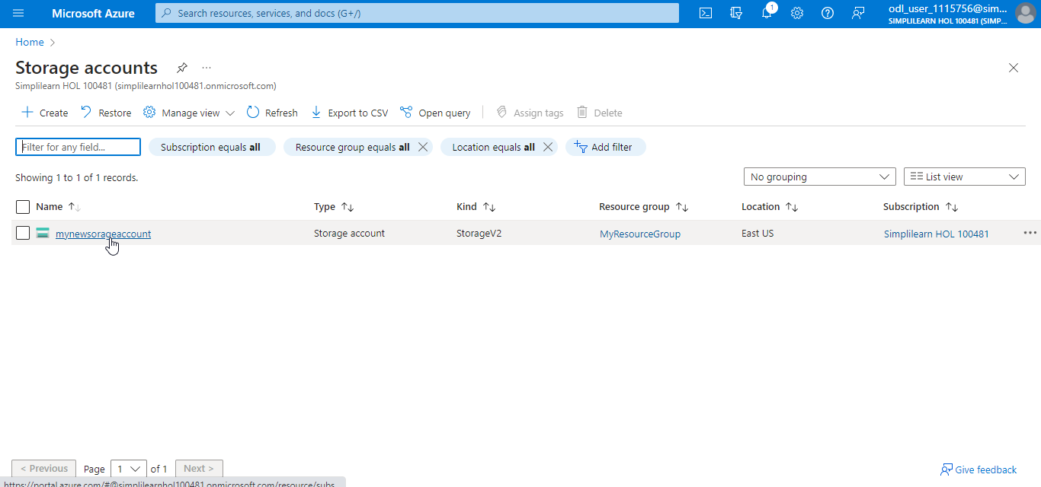

- Under Settings, choose Configuration

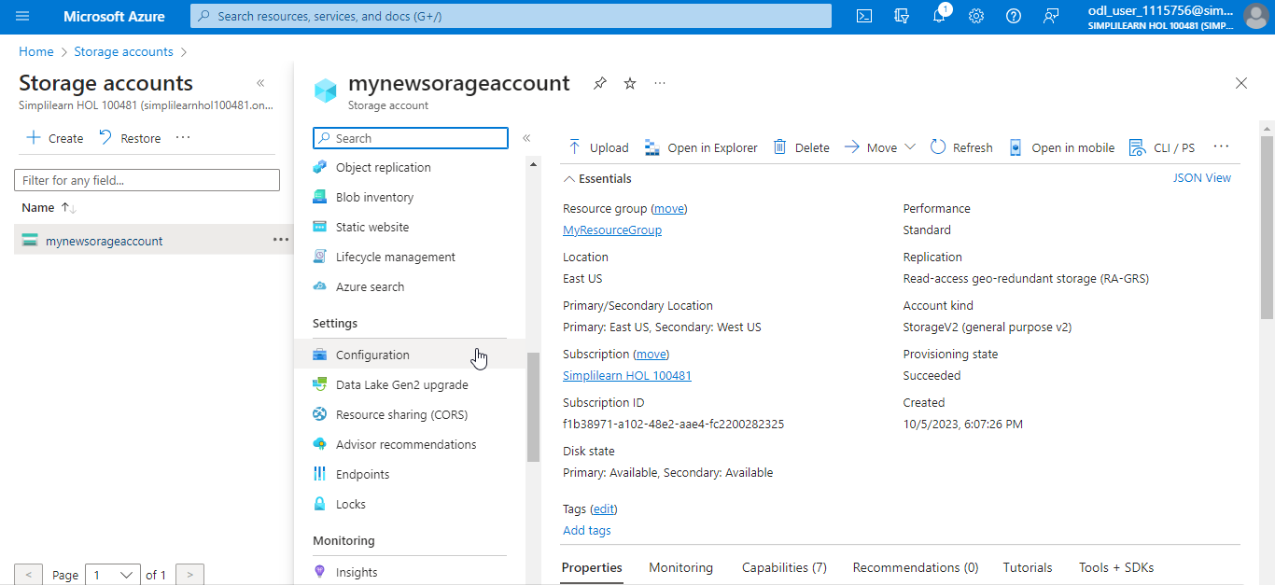

- Under Allow Blob anonymous access, choose Enabled

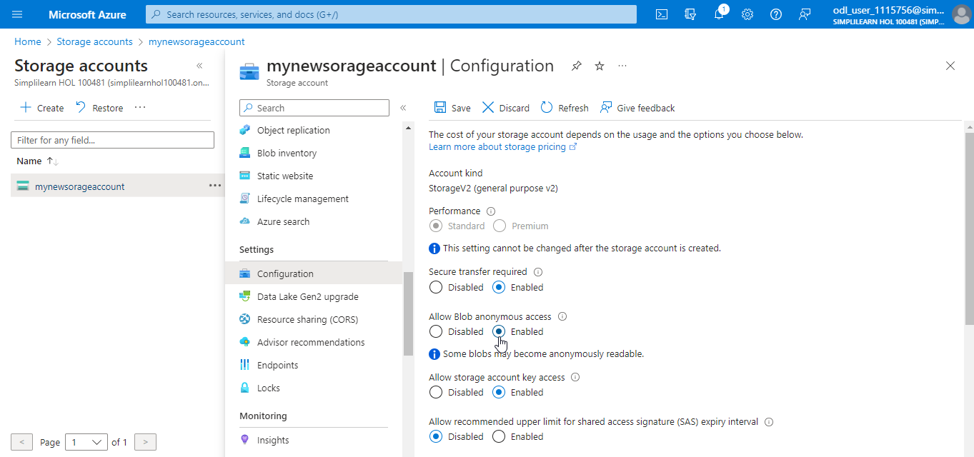

- Click on Save

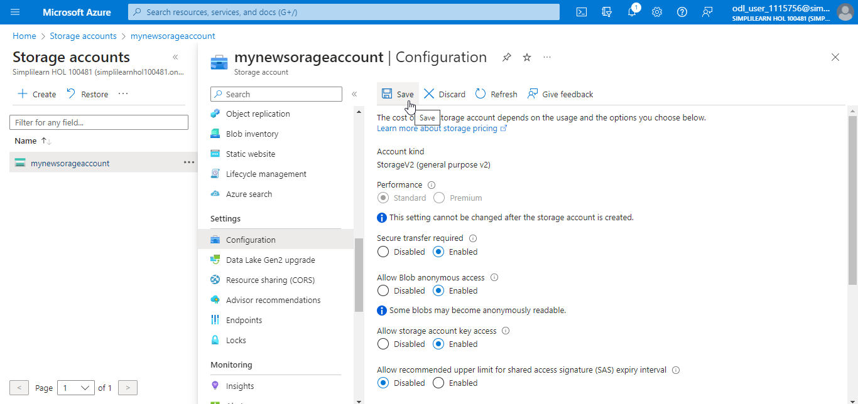

The storage account is updated successfully as shown below:

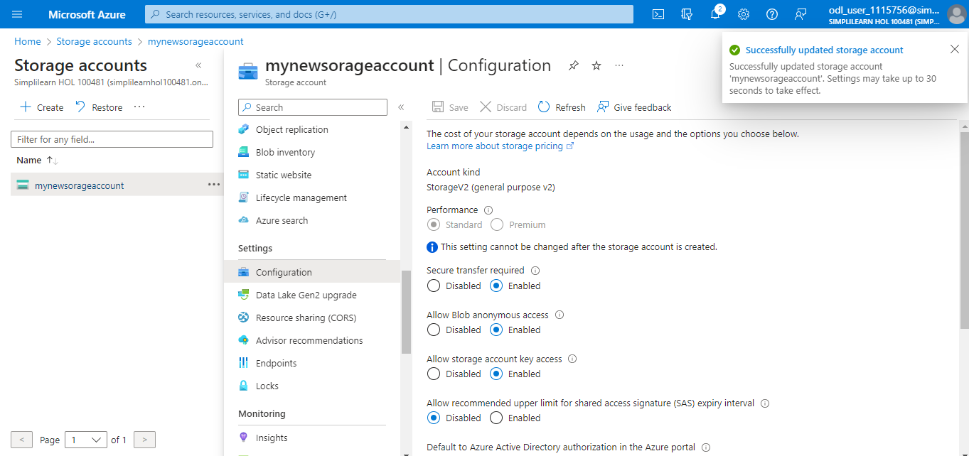

- Navigate to Containers under Data storage

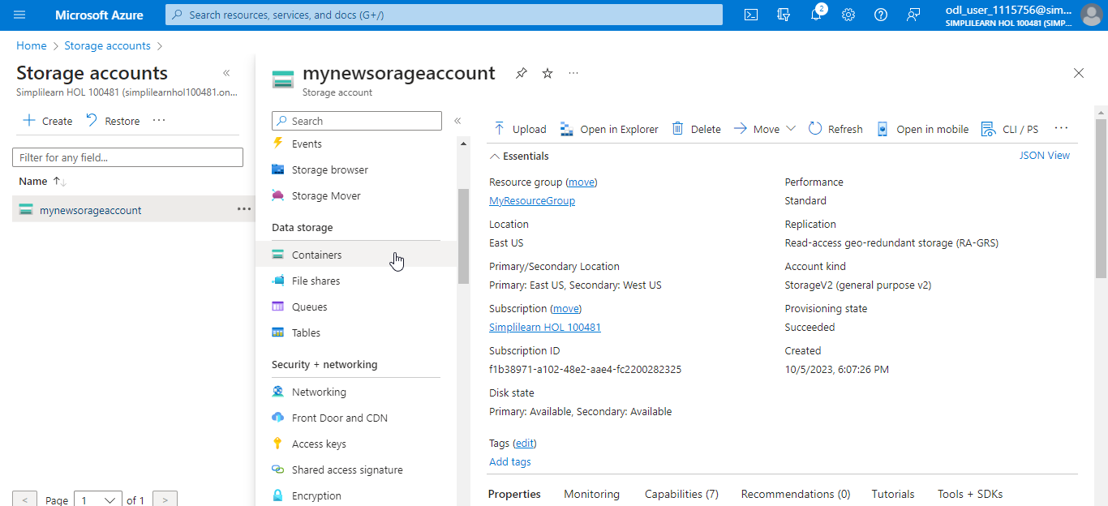

- Choose the containers for which you want to set the public access level

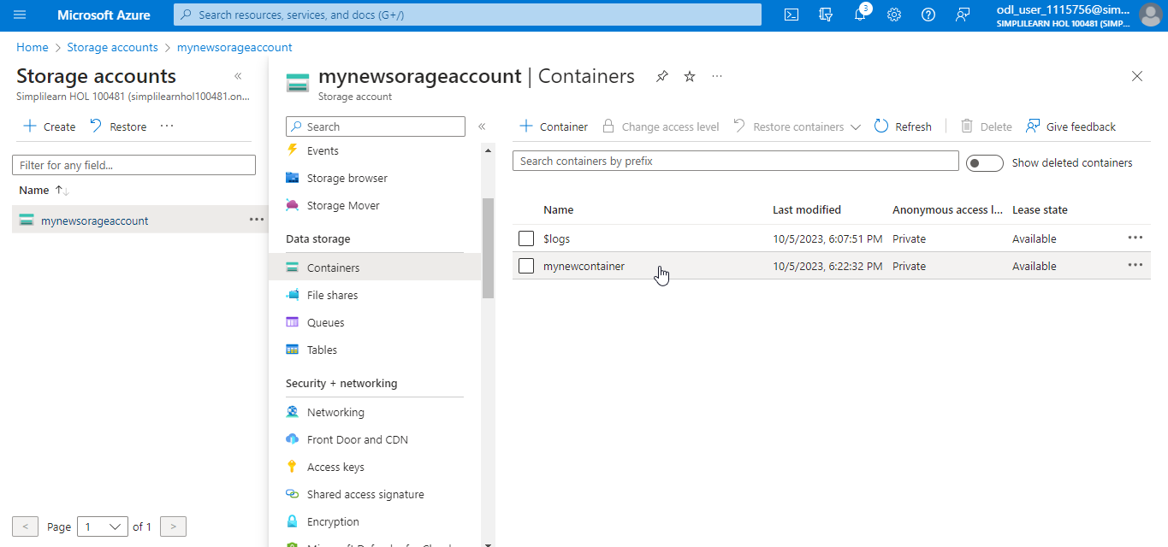

- Click on Change access level and select Private (no anonymous access)

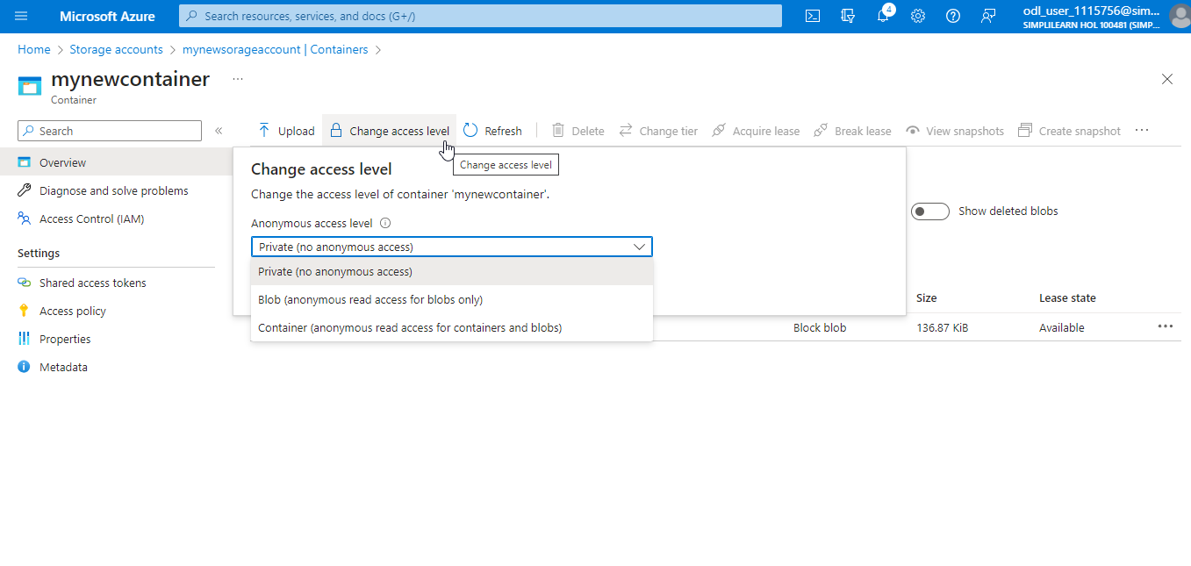

Note:
- Private (no anonymous access): The container and its blobs can be accessed only with an authorized request. This option is the default for all new containers.
- Blob (anonymous read access for blobs only): Blobs within the container can be read by anonymous request, but container data is not available anonymously. Anonymous clients cannot enumerate the blobs within the container.
- Container (anonymous read access for containers and blobs): Container and blob data can be read by anonymous request, except for container permission settings and container metadata. Clients can enumerate blobs within the container by anonymous request but cannot enumerate containers within the storage account.

- Click on OK

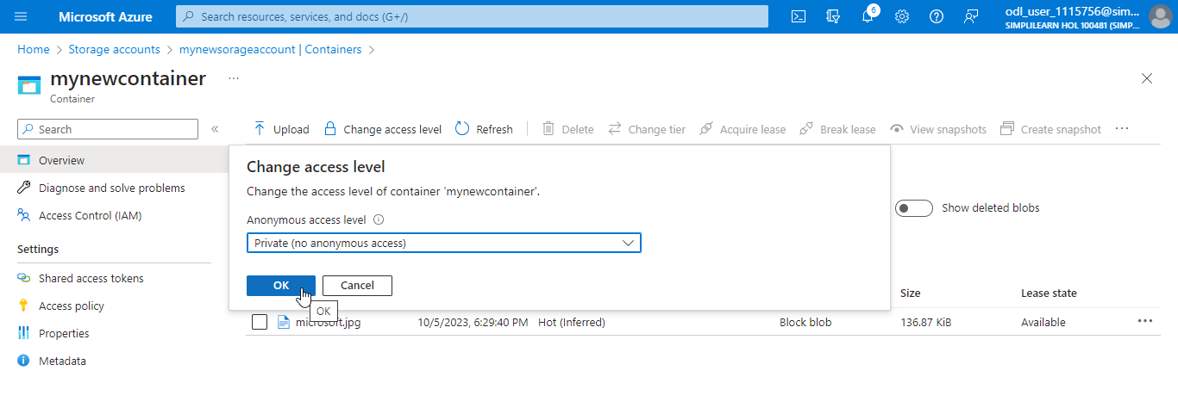

The access level is changed successfully for the container as shown below:

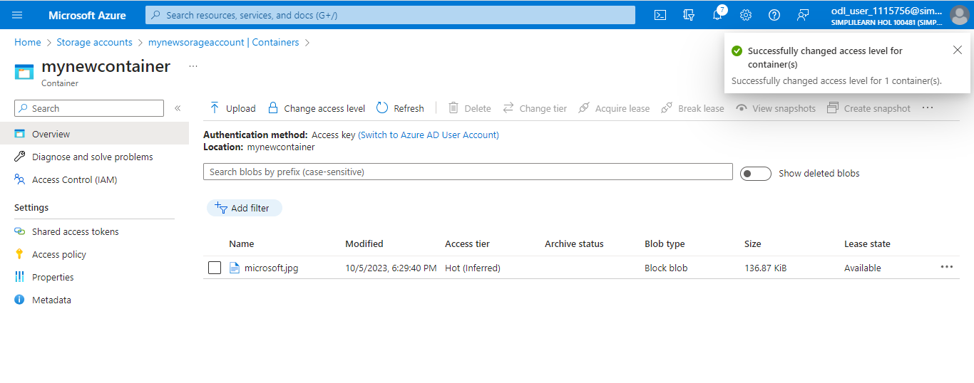

You have successfully changed the access level for the blob storage container.

